The Prayer

B | I pray you’ll be our eyes 234.
A | And watch us where we go 234.
B | And help us to be wise 234.
A | In times when we don’t kno 234_ow
C | Let this be our prayer 234.  When we lose our way 234.
All | Lead us to a **-place**  Guide us with your **_grace**  To a *-place ^where we’ll _be* safe  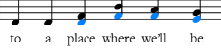
C/B | La luce che tu dai, I pray we’ll find your light  La loo-cha kay to die
C/A | Nel cuore restera, And hold it in our hearts_  Nell core a rester-ah
C/B | A ricordar^ci _che, When stars go out each night  A re-cord archie kay
A | L’eterna stella sei(234)_ei  Let turn a stella say
B/C | Nella mia preghie—ra--------------a,  Nell a Mia prey-gerra Let this be our Prayer
A/C | Quanta fede c’e, When shadows fill our day  Qanta fay day chay

All | Lead us to a **_place**  Guide us with ^**your _grace**  Give us *-faith ^so we’ll _be* safe  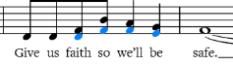
All** | Sognamoun **mondo senza piu violenza**  Son yam un mondo senza pure voi-len-za  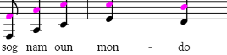
Un mondo **di giustizia e di Speranza**
Un mondo dee just-eez-ia dee spare-anza
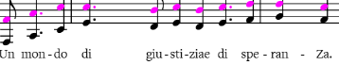

All * | *Ognuno dia la manoal suo vicino  Oh you know dee la manhole so vee-chino
Simbolo di pace di fraternita…_*
Sym-bowl-o dee patch-ay dee fratern-eet-ah
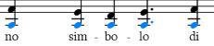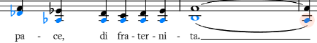
A /C | La forza che ci dai, We ask that life be kind  La forch a kay chee die
B/C | E’il desiderio che, And watch us from above  Eel dess -ee- derrio kay
B&C/A | O*gnuno trovi a* mor, We hope each soul will find  Oh you know trove- ya-more
B&C/A | Intornoe dentro se…………………………..^_,  In torno den-tro say Another soul to love
All  A&C  B&C  All | Let this *be our* pray  Just like every child 2,3,4/1,2,3.  Need to find a _place  Guide us with your gr_a_ce  Give us faith ^-*so we’ll _be *__sa__fe**
All A_  A&C  All | E la fede che, Hai access sion *noi*  Ella fay day cha, Hi a chess oiy noiy  Sento che ^ci sal_ve^ra. . .  Sen-toe kay chee sal-vay-rah  Sal. *ve. ra* . . . . . . .__a  sal-vay-rah

