She’s a Rainbow
All | She *come’s in colours everywhere* . .
 | She combs her hair . . *She’s like a rainbow*
*coming colours in the air*, *Oh everywhere*
X2
She comes in colours*Wah, wah, *la, la, la**
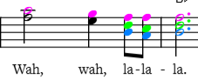
 | ~~~~~~~
All | Have you seen her dressed in **blue** . . ./.
 | See the sky in front of **you** . . ./.
 | And her face is like a **sail**- speck of white so fair and **pale**
 | Have you seen a lady fair-er
All | She comes in colours everywhere . .
 | She combs her hair . . *She’s like a rainbow*
 | *coming colours in the air* *Oh everywhere*
 | She comes in *colours* *wah, wah, *la, la, la**
 | 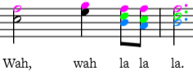
All | Have you seen her all in **gold** . . ./.
 | Like a queen in days of **old** . . ./.
 | She shoots her colours all a **round**- like a sunset going **down**
 | Have you seen a lady fair-er
All | She comes in colours everywhere . .
 | She combs her hair . . *She’s like a rainbow*
 | *coming colours in the air* *Oh everywhere*
 | She comes in *colours* *wah, wah, *la, la, la**

