Up On The Roof
All | When this old world starts getting me down
 | And people are just too much for me to face
 | I climb way up to the top of the stairs
 | And all my cares just drift right into space
All | *On the roof it’s peaceful as can be*  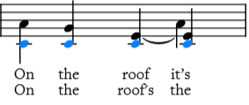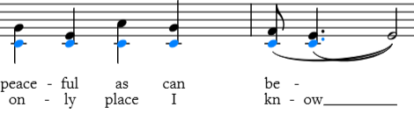
All A_ | And *there the world below can’t bother me*  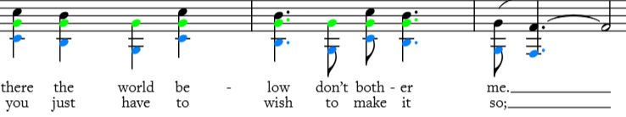
All | So when I come home feeling tired and beat
 | I’ll go up where the air is fresh and sweet (up on the roof)
 | I’ll get far away from the hustling crowds
 | And all that rat-race noise down in the street (up on the roof)
All | *On the roof’s the only place I know*
All A_ | Where *you just have to wish to make it so*
 | Up on the *roof*
A&B | At *night the stars put on a show for* free
C | And darlin’ you can share it all with me
All | I keep a tellin’ you that right smack dab in the middle of town
 | I found a paradise that’s trouble proof
 | And if this world starts getting’ you down
 | There’s room enough for two up on the *roof*
 | There’s *room enough for two up on the *roof.**

